FUELd

Items for Discussion

Sales Reporting:
Reporting via products. Are we able to run a report for what product were sold in a particular time frame?
Throughput / Gallons / Products sold i.e.

We currently use a spreadsheet. See attached snapshot.
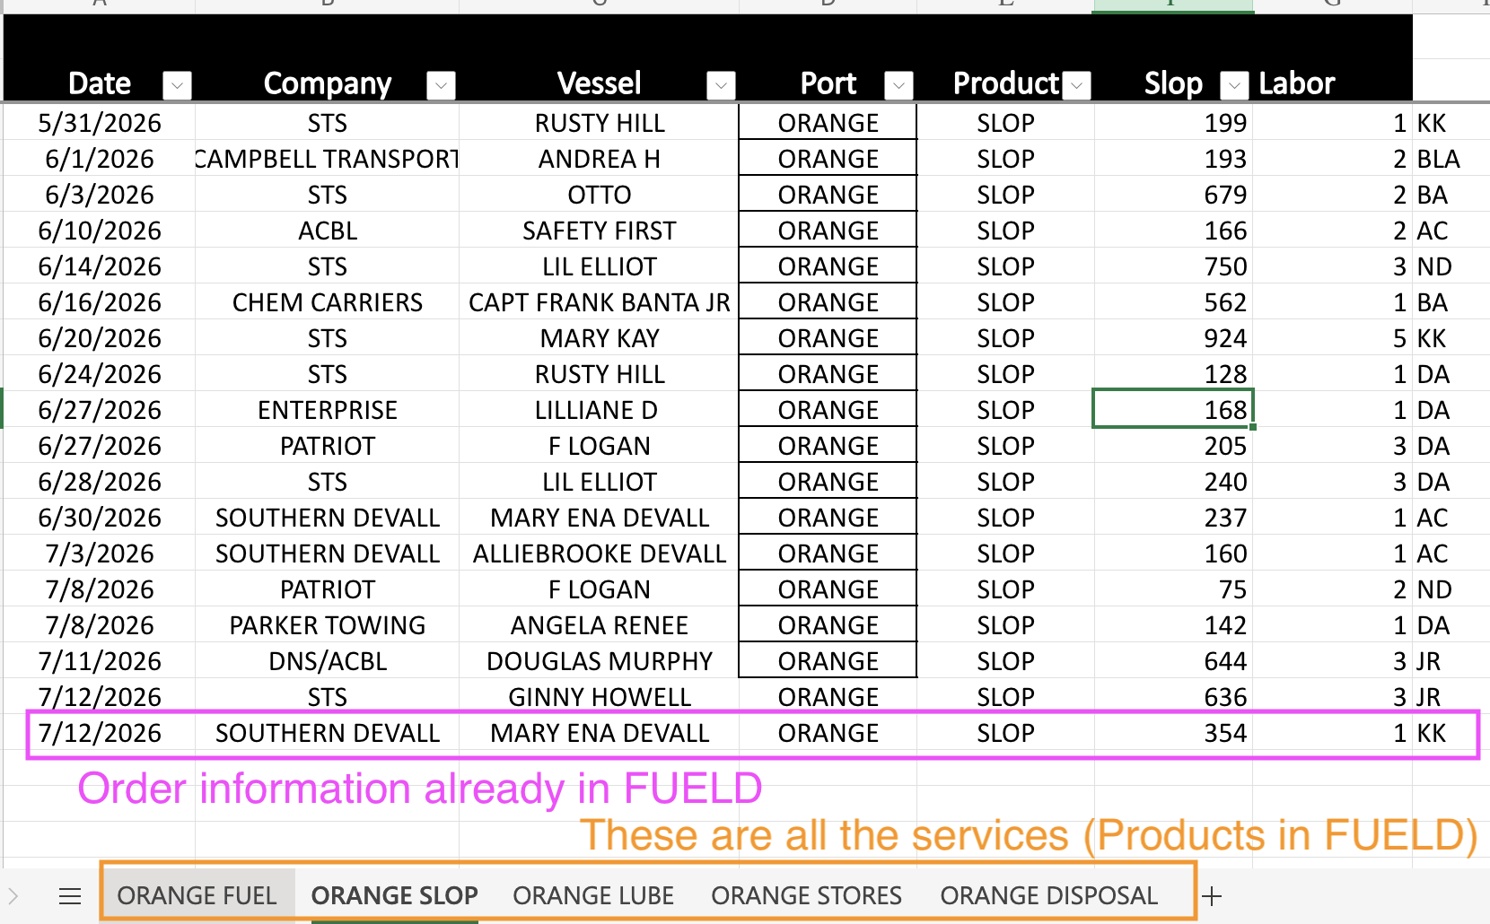
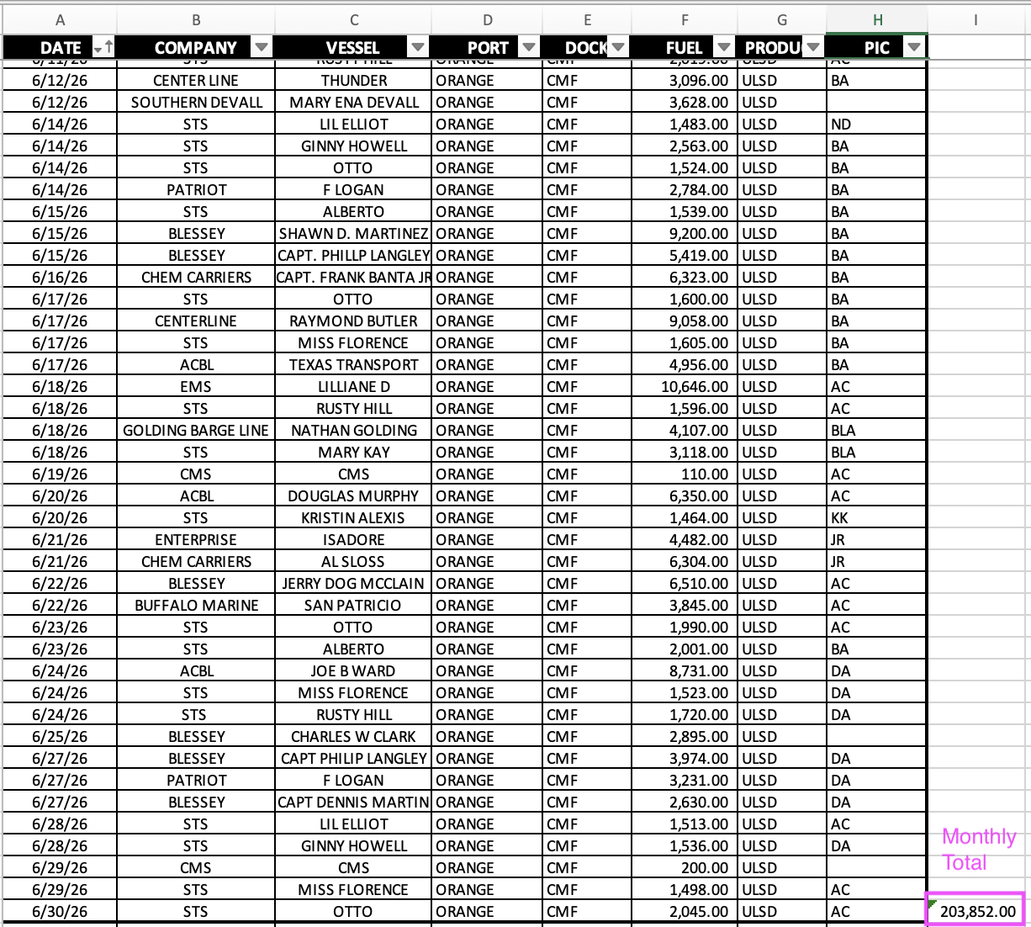

System Comments Updates / Rundown / Email
What is the best way to do something like this? So teams are aware of comments made new entries etc? At ENDOFA we had that daily email that came out with all comments made. How is Riviera doing that?

OPS Board / Barge Schedule:
Can we update the OPS Board to make something to match the Barge Schedule sheet. Line items will need to be able to be moved to be put in order of importance.

Sent you a link to the current barge schedule tracking that we use. I want to see if we can tweak the OPS board to be more like this sheet as the team is quite used to it.

Additional Modules:

- ⁠QuickBooks Integration
How does this work? Right now I have the orders being processed in the FUELD system, then I send the Invoice to Backoffice (Kathy@channeltx.com) and she inputs the FUELD invoices into QB and sends everything out from there.

I know this integration will be a bit, but is there a way to tie the 2 together so products/services and pricing are synced?

- ⁠Automatic Updates for Service based projects.
Currently updates were generated from ChatGPT in the following format:

- Final report for projects.
PDF previously sent. This is what is sent to all our clients after the job is completed (SERVICES ONLY). I think we have all the information in the system already to prepare these automatically. We currently have a human prepping them and it takes forever.
- Upload photos

- Daily Pricing Email for Fuel Dock
Daily pricing email is sent out via email every morning. Is there a way to integrate this into the system so it comes out from the system. Once an order is delivered the pricing from the date of delivery is applied. This is strictly for the CMF FUEL DOCK as we use a posted price there?

Current Email Format below.
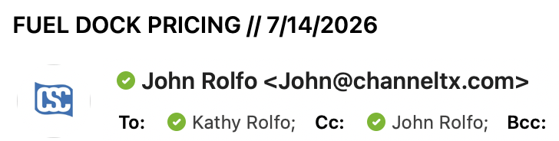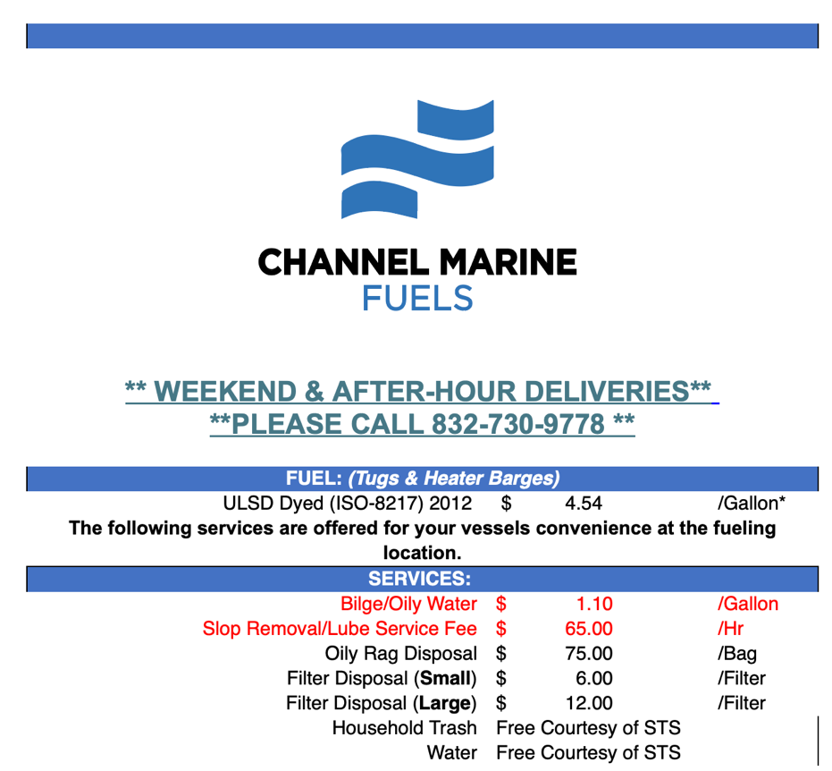
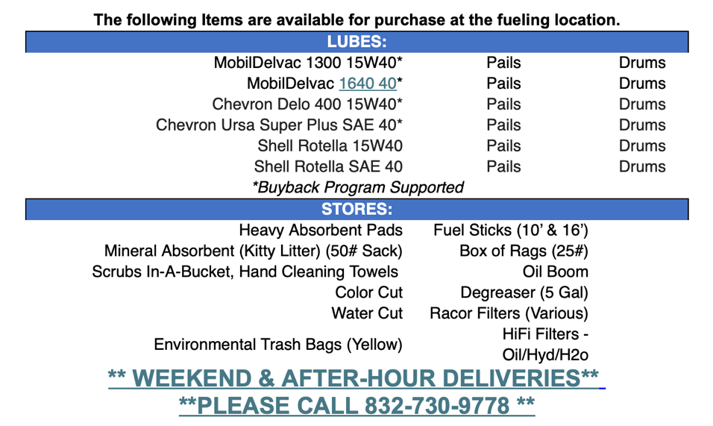

Finalized Pricing For Users?

